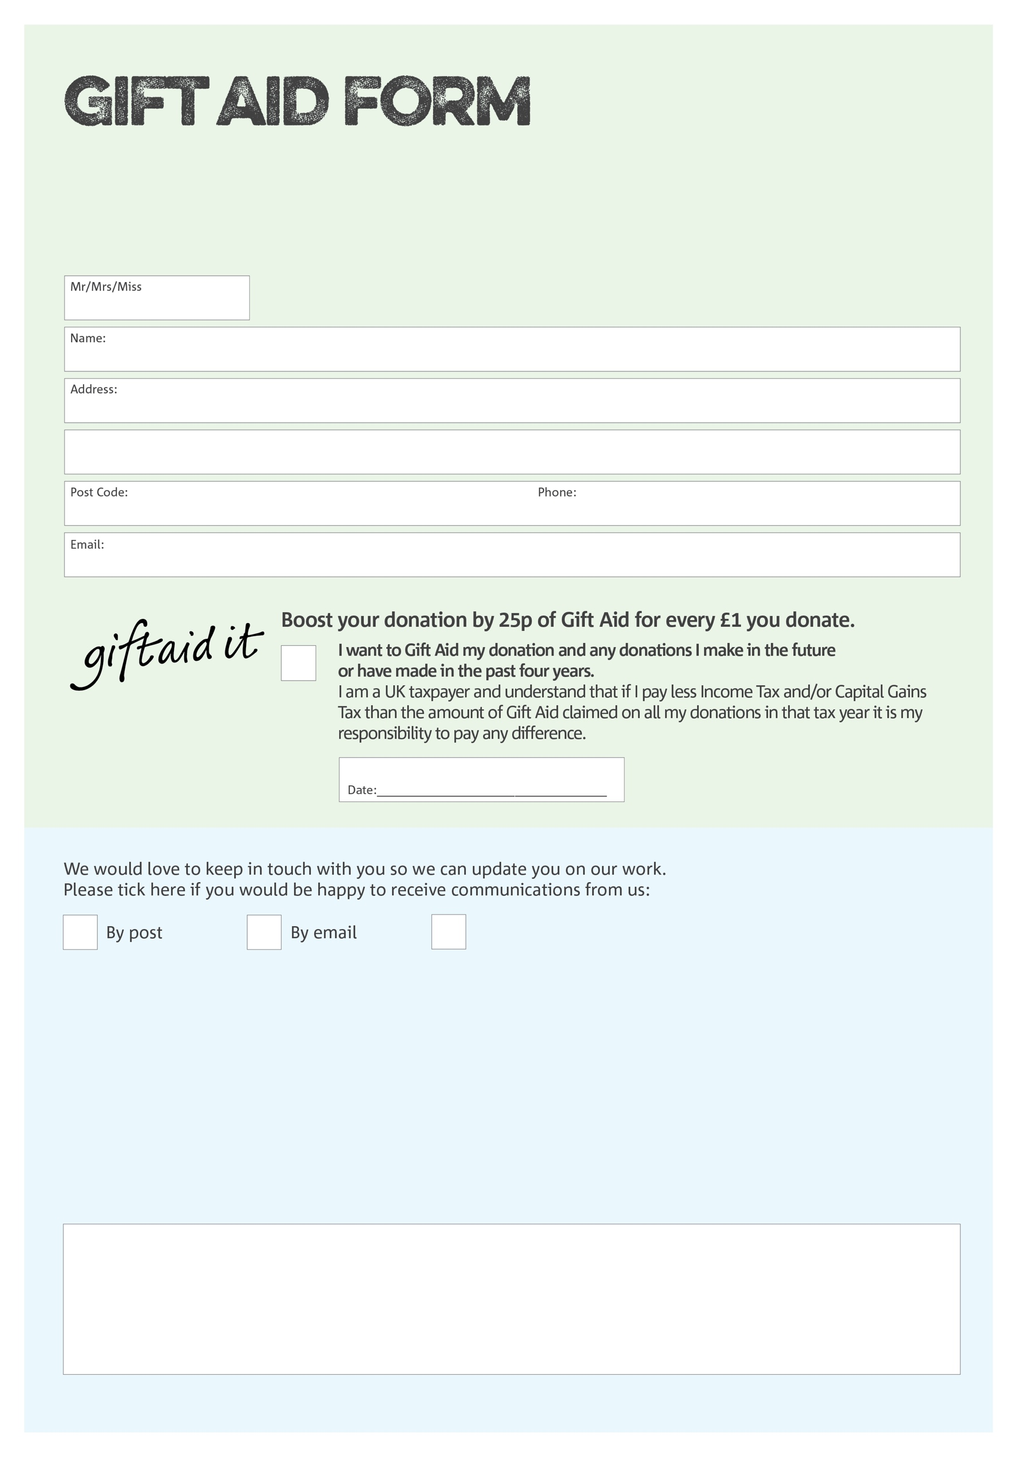

By filling in this form Whitchurch Foodbank will receive an extra 25p for every £1 you give at no extra cost to you. Thank you!

We would love to know why you have chosen to donate to Whitchurch Foodbank. If you would like to share your motivation let us know below:
Data protection

Whitchurch Foodbank is committed to protecting your privacy and will process your personal data in accordance with current Data Protection legislation. Whitchurch Foodbank collects information to keep in touch with you and supply you with information relating to our work. To unsubscribe from our newsletter, send a message to the email address above with the word unsubscribe in the subject line. A full data privacy statement for financial donors is available from the foodbank on request.’

You can change your preferences any time by contacting us on 01948 663943 or emailing us at info@whitchurch.foodbank.org.uk
I do not wish to receive future communications from Whitchurch Foodbank
Reg. CIO Charity No: 1213329 Reg. in England & Wales
POSTAL ADDRESS Whitchurch Foodbank, Bargates Hall, Church Street, Whitchurch, Shropshire SY13 1LB

Charity Number 1153274. Registered in 2013

