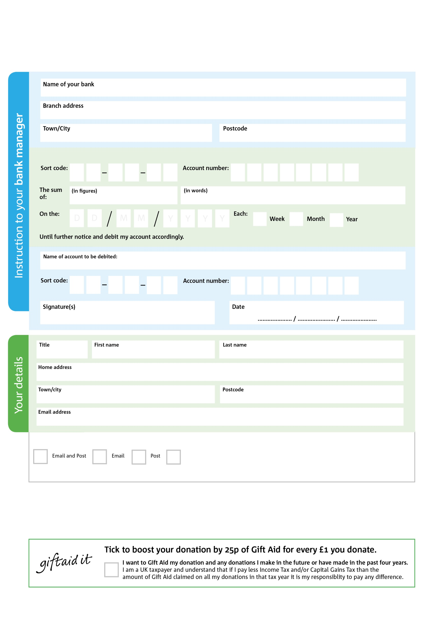
Standing Order Mandate
www.whitchurch.foodbank.org.uk


We would love to keep you up to date with information about Whitchurch Foodbank. Please tick your preference:

You can change your preferences any time by contacting us on 01948 663943 or emailing us at info@whitchurch.foodbank.org.uk

Data protection
‘Whitchurch Foodbank is committed to protecting your privacy and will process your personal data in accordance with current Data Protection legislation. Whitchurch Foodbank collects information to keep in touch with you and supply you with information relating to our work. To unsubscribe from our newsletter, send a message to the email address above with the word unsubscribe in the subject line. A full data privacy statement for financial donors is available from the foodbank on request.’



V

V

V

V

V

V

I do not wish to receive future communications from Whitchurch Foodbank

Reg. CIO Charity No: 1213329 Reg. in England & Wales
POSTAL ADDRESS Whitchurch Foodbank, Bargates Hall, Church Street, Whitchurch, Shropshire SY13 1LB

2
0

V

V1

V1

V1

V1

V1

V1

V1

V1

V1
V

V1

Please pay Whitchurch Foodbank,

6
V
1

V
2
1

V
2
V
4

V
6

V
1

V
1

V
4

V
5

V
2

V

V

V

V

V
Please copy this form and send the original to your bank or building society and
send the copy to Whitchurch Foodbank, using the address at the bottom.

