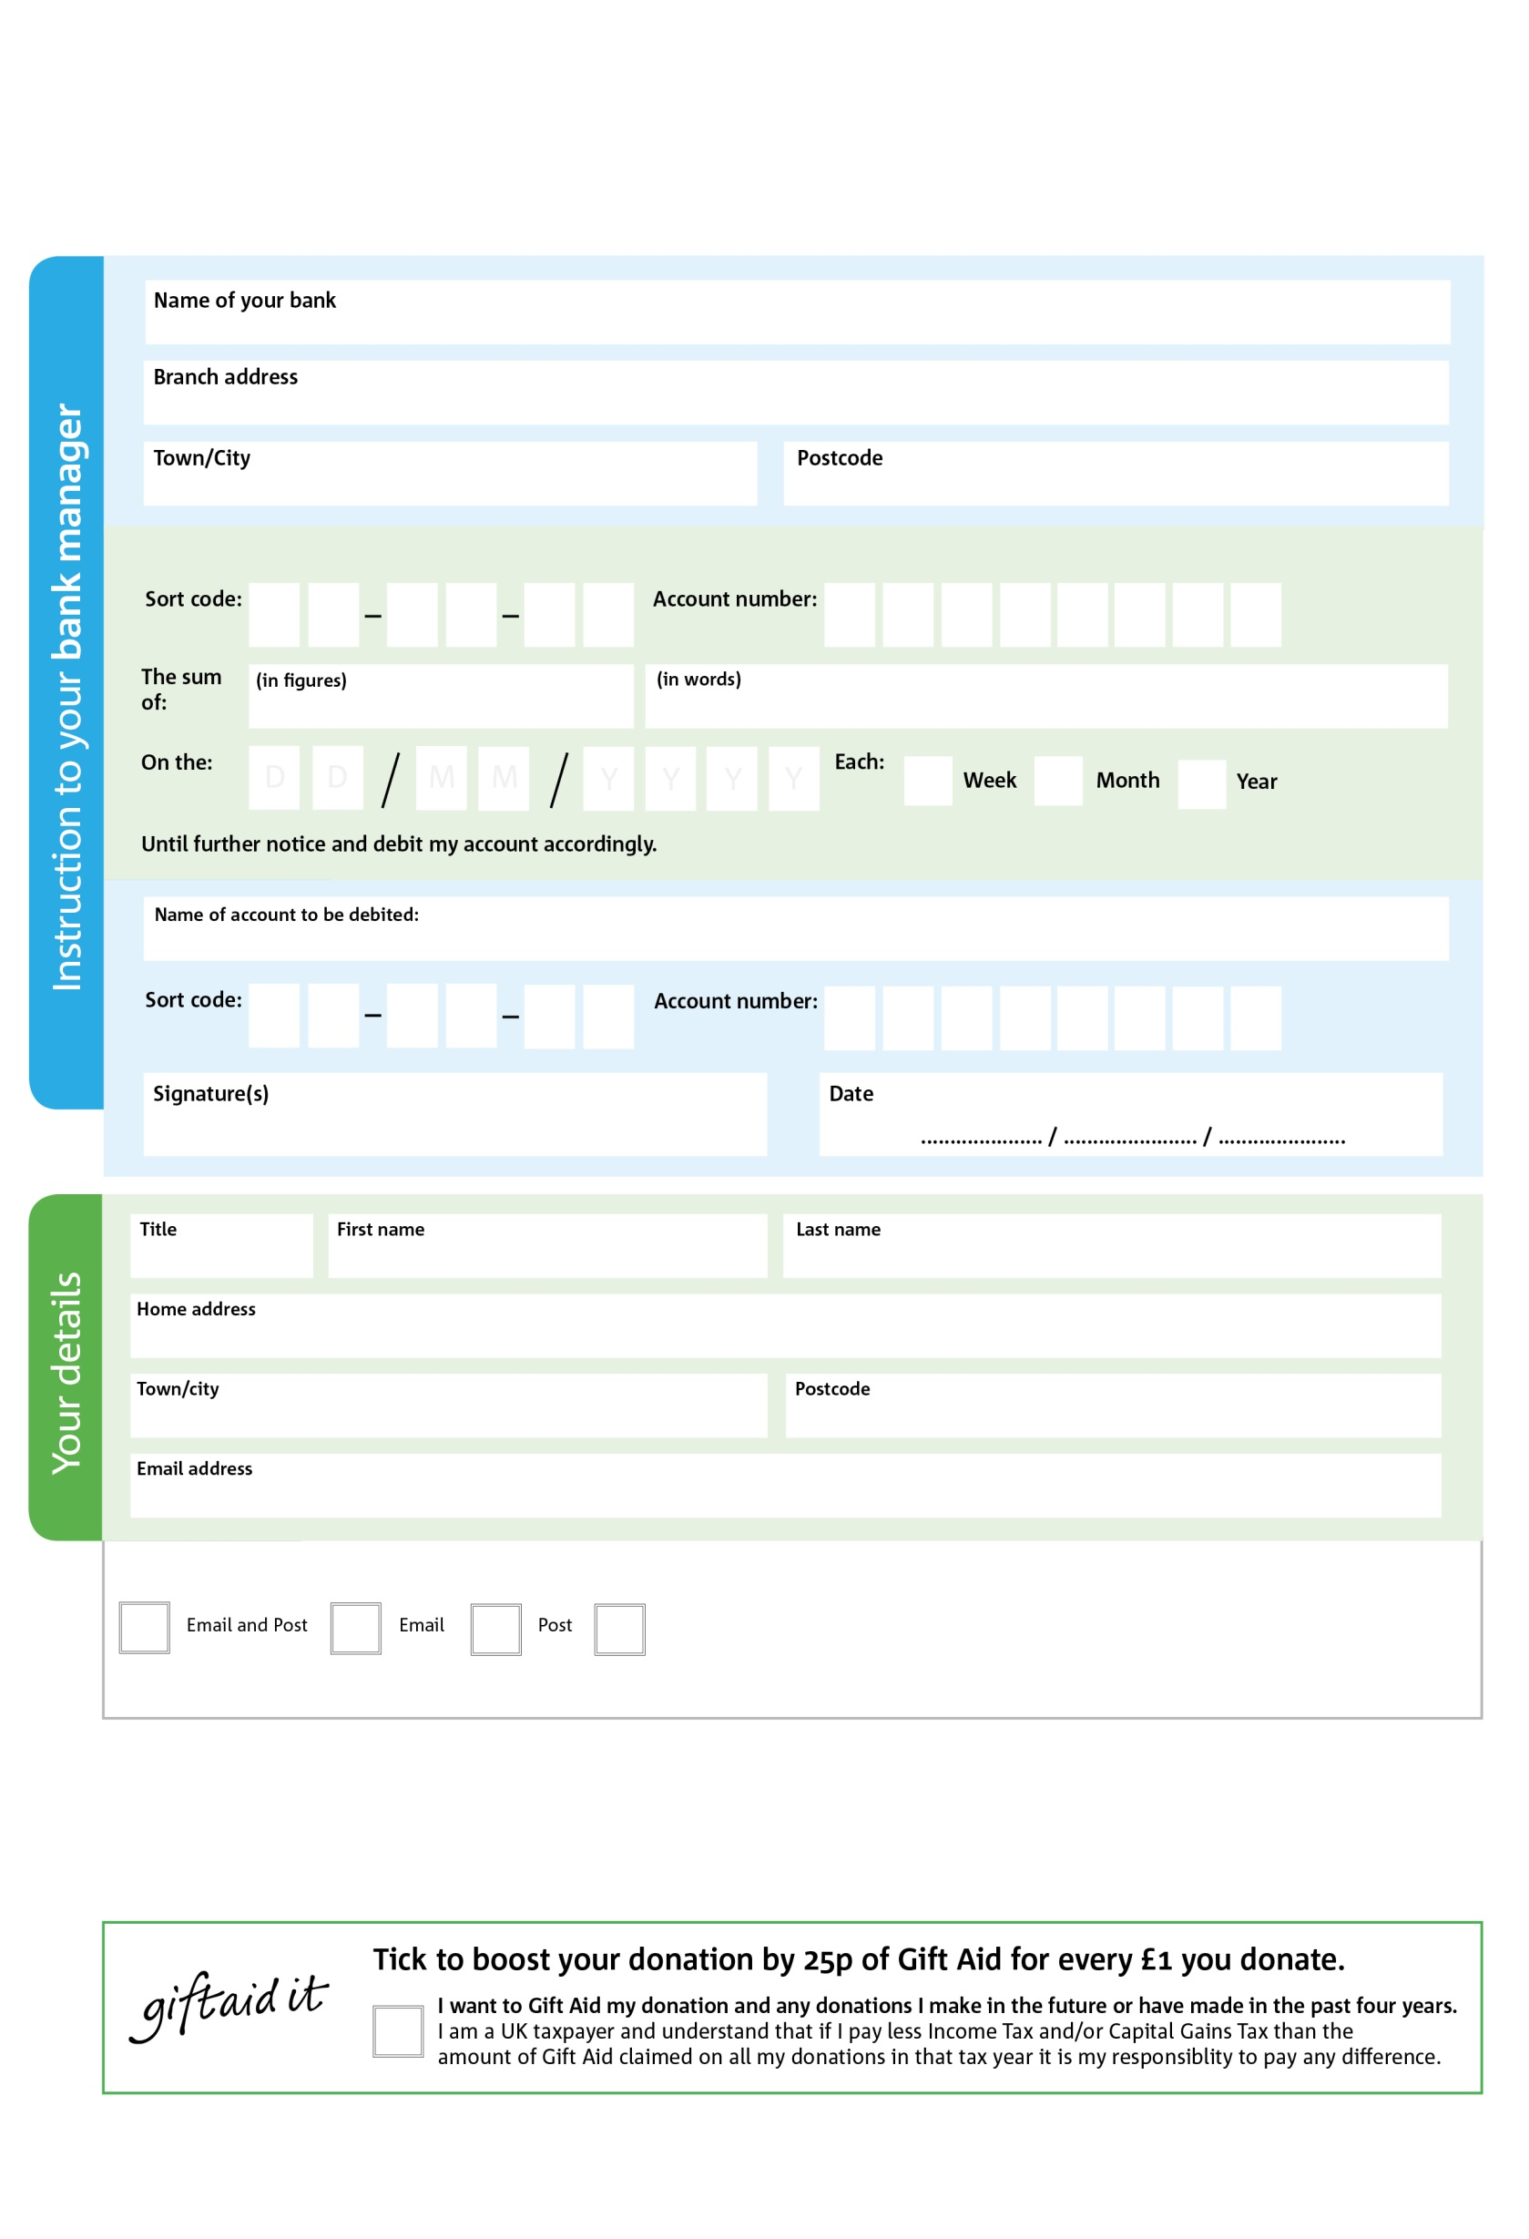

**Standing Order Mandate**

**www.whitchurch.foodbank.org.uk**



9X

V

3X

V

8X

V

6X

V

1X

V

9X

V

3X

V

6X

V

5X

8X

7X

7X

0X

2 X

Please pay Whitchurch Foodbank,

Reg. Charity No: 1153274 Reg. in England & Wales

POSTAL ADDRESS Whitchurch Foodbank, Bargates Hall, Church Street, Whitchurch, Shropshire SY13 1LB

I do not wish to receive future communications from Whitchurch Foodbank

**Data protection**

*‘Whitchurch Foodbank is committed to protecting your privacy and will process your personal data in accordance with current Data Protection legislation. Whitchurch Foodbank collects information to keep in touch with you and supply you with information relating to our work. To unsubscribe from our newsletter, send a message to the email address above with the word unsubscribe in the subject line. A full data privacy statement for financial donors is available from the foodbank on request.’*

**Please pass this form onto the foodbank, using the foodbank’s address at the bottom, who will save a copy for their records.   
They will then send it onto your named bank or building society.**

You can change your preferences any time by contacting us on 01948 663943 or emailing us at info@whitchurch.foodbank.org.uk

We would love to keep you up to date with information about Whitchurch Foodbank. Please tick your preference: